# CS 255 System Design Document Template

This template lays out all the different sections that you need to complete for Project Two. Each section has guidance to prompt your thinking. You will need to continually reference the interview transcript as you work to make sure that you are addressing your client’s needs. There is no required length for the final document. Instead the goal is to complete each section based on what your client’s needs are. Remove this note when you are finished, and replace all bracketed text with the relevant information.

## UML Diagrams

### UML Use Case Diagram

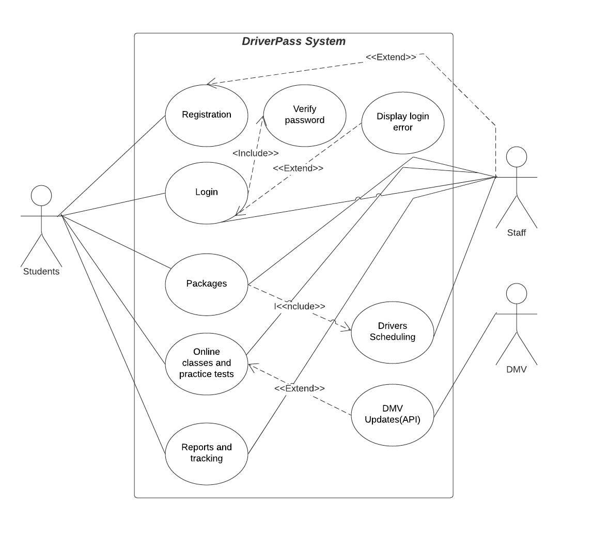

### UML Activity Diagrams

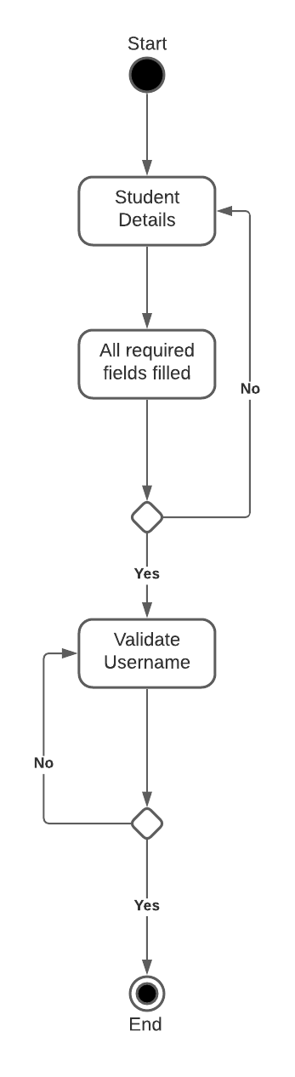

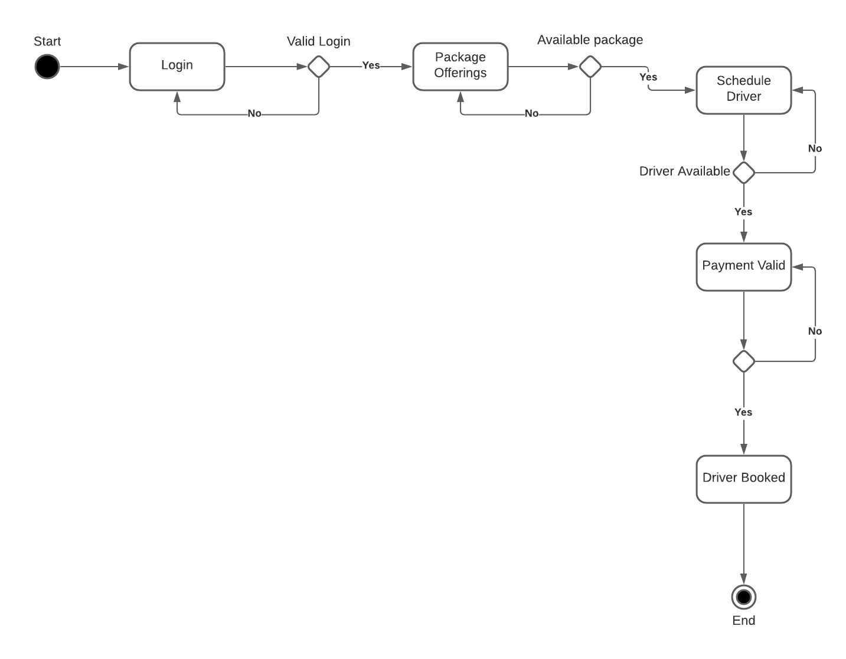

### UML Sequence Diagram

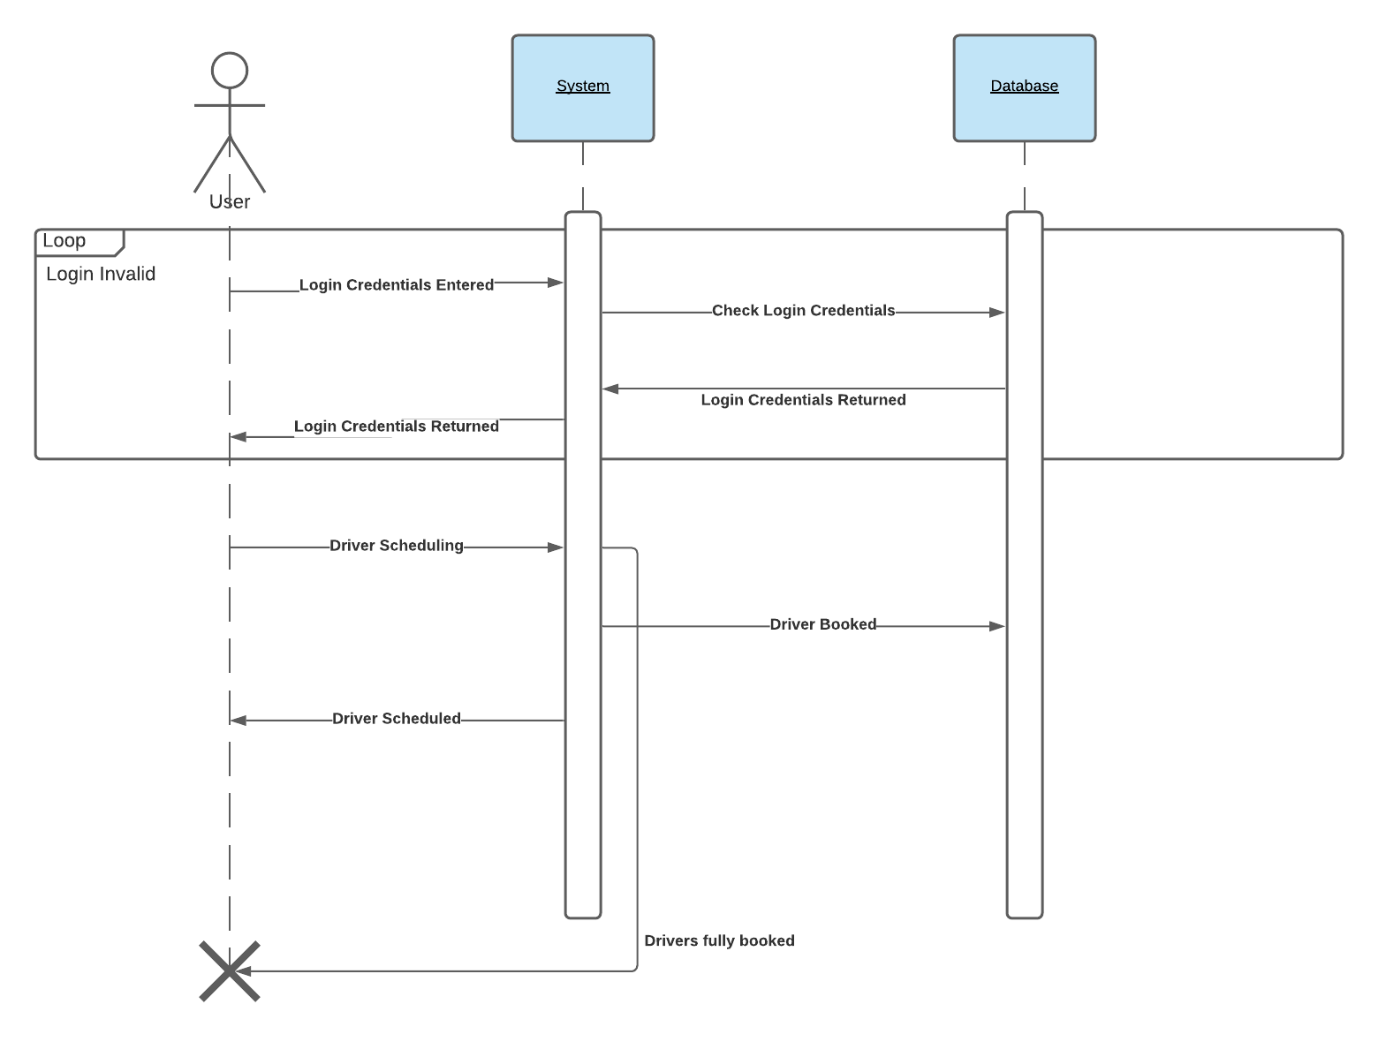

### UML Class Diagram

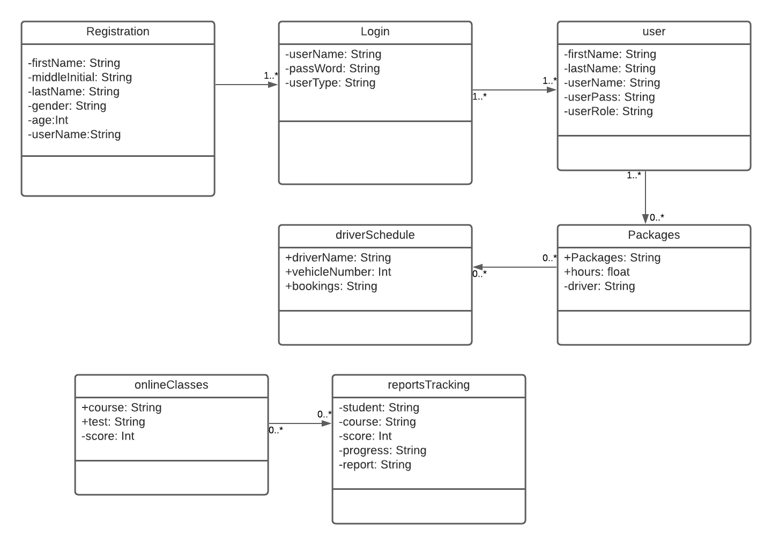

## Technical Requirements

The DriverPass system requires three Dell servers. One server for the online portal, the second server database, and the third sever is the DriverPass application. Custom developed application (mix of C++ and Java). A combination of Windows and Linux for the operating platforms. An Scrum-agile tools and methodology will be used to build and provide updates. These servers will be housed in the Dell cloud environment.